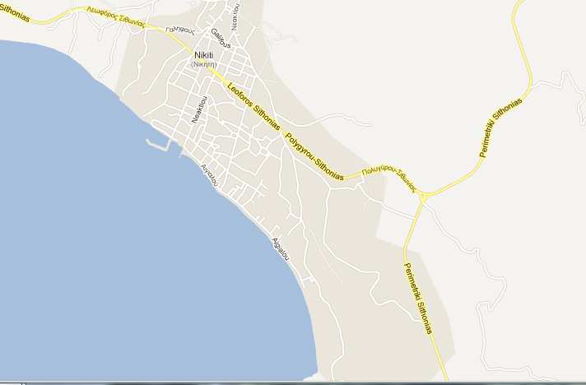
Lina housepored puta 2km ispred nikitija
+30 6976688816
Mob. (+30) 6977218067
Kassandrinos
Mob. (+30) 6977218067
Minas
tel: +30 6972551118
House Anna
Mob (+30) 6946191308
Elli
0030 23750 22 642
Karali
6932 651486
Sapho

