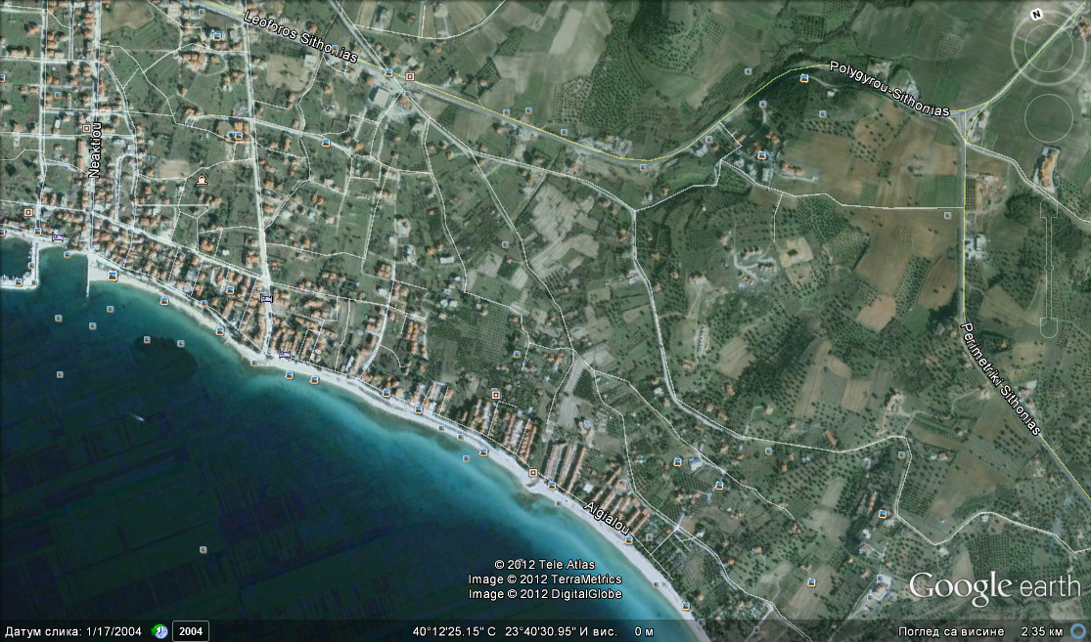
House Anna
Mob (+30) 6946191308

