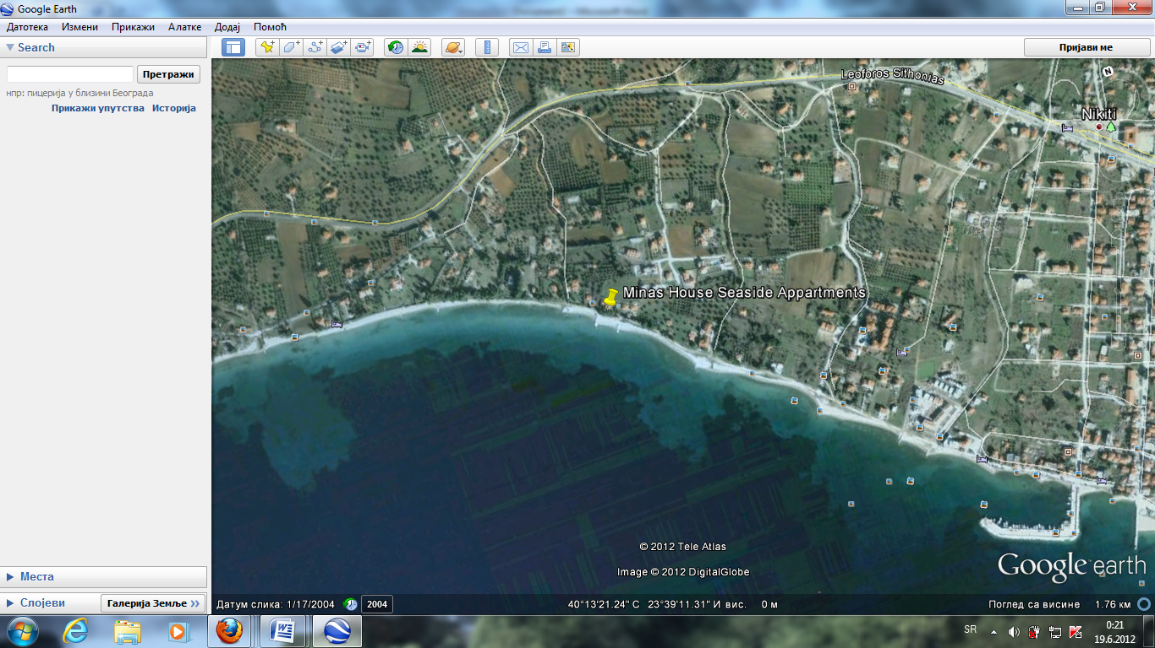

Lina housepored puta 2km ispred nikitija

+30 6976688816

Mob. (+30) 6977218067

Vila Elli